Customer Lifetime Value (CLV)

CLV introduction
- Companies can assess customers in terms of their worth to the company. Some customers are costly to acquire, some are “cheap” to acquire but costly to retain
- CLV = NPV of cash flows attributed to the relationship with a customer. Useful as it shows us how much marketing department should spend to acquire a customer
  - Key goal is to help firms understand the profitability of the various customer segments it is considering serving

Required inputs
- Acquisition costs (mainly comprised of marketing costs)
- Retention costs: costs of inducing the consumer to continue their consumption in future periods
- Retention rate: fraction of customers who are retained and consume in future periods
  - A function of marketing spending – the equation oversimplifies this
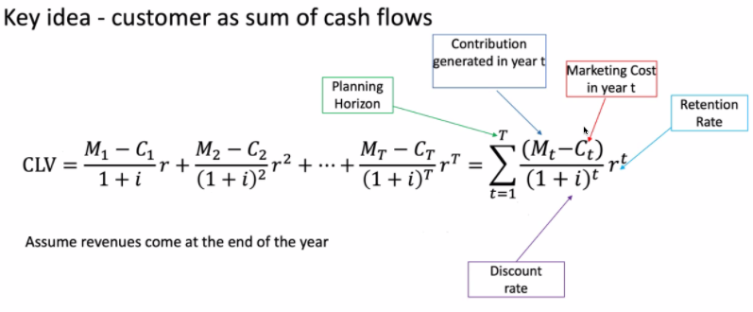
- Average contribution per customer: revenue generated minus cost of goods sold
- CLV is the maximum acquisition cost the firm should be willing to pay
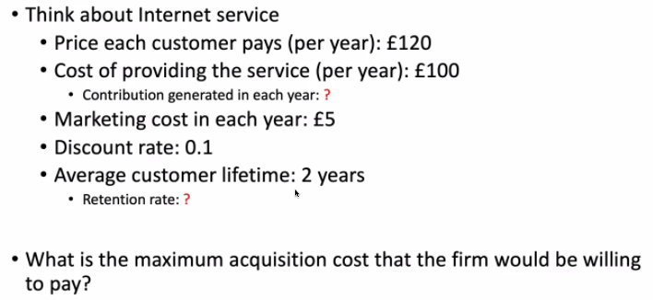
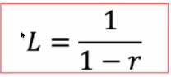
- Would need to factor in importance of the customer as a network node, giving rise to network effect, on top of the CLV.

- M = 15, I = 0.1, r = 0.5
- CLV = 15*0.5 / (1+0.1-0.5)

Treatment of acquisition costs
- Ignore acquisition costs when calculating CLV, and acquire customers whose CLV > acquisition costs
- Consider acquisition costs when calculating CLV (margin – acquisition cost) and acquire customers whose CLV > 0

CLV Applications and implications
- Helps us choose the most profitable customers
- Carefully monitor acquisition costs
- Increase retention and decrease churn through customer service and targeted communications. Increase contribution margin through upselling and cross-selling
- Drop low CLV customers or offer lower service levels to them

Drivers of CLV

Customer acquisition
- Costs of customer acquisition include advertising, salesperson hourly salary x hours for B2B acquisitions, cost of offering free trials, legal costs.
- Costs of acquisition can be more subtle. For example, when releasing a free app, the cost of acquisition may appear to be 0, but if there is a paid version, the free version will likely cannibalise the sales of the paid version. This lost revenue should be considered an acquisition cost.
  - Opportunity cost of time and money is an acquisition cost
  - Potential loss of reputation if quality falls as capacity expands quickly

Retention rate
How can we increase retention rate, noting that it is a function of marketing cost?
- Retention rate is affected by reputation and service quality, which can be a function of capacity utilisation (Groupon nail salon example).
- Likely that firms are frequently focusing too much on acquisition and not enough on retention, thus underinvesting in retention. Why?
  - Not as tangible and harder to measure
  - Firms may overestimate retention rate and underestimate required effort
- Loyalty programmes, such as frequent flyer programmes, induce customer inertia and loyalty by creating subtle switching costs through sunk costs.
  - Firms could also increase switching costs through contracts with cancellation fees, bureaucracy. These create consumer inertia thus increase retention rates.
- Subscription models are essentially more formalised loyalty schemes. Many provide a free initial purchase, which represents an acquisition cost.
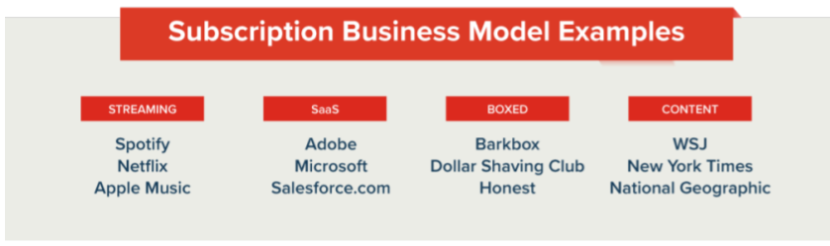
  - They can also increase hurdles by making it hard to unsubscribe, plus there are endowment effects and status quo biases

Margin size
- Profit maximisation issue – drive up revenue and drive down costs. Differentiate and target niche segments – tailor your product to their needs and they will have a higher WTP

CLV-based firm valuation
- Summing up all CLVs to value the firm, has become a mainstream metric of firm valuation
- McCarthy and Fader (2018) – have to be careful that acquisition costs don’t exceed the NPV of future profits. After they published results of a firm whose acquisition costs > NPV, the firm’s share price dropped. Highlights the importance of CLV in valuation
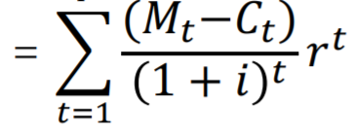

Decomposing firm value
Firm value = customer number in market x customer market share x CLV (margin, retention)
- Environment determines the number of customers in the market
  - Primary demand is the interest in an entire class of products, and not any one specific brand/product. It is determined largely by the PEST macro environment
      - Economic and political factors: Zoom profits doubling and travel firms struggling during pandemic.
      - Social factors: lululemon benefiting from an increasing demographic of single, self-sufficient women
      - Technological factors: self-driving technology, rise of online dating sites due to increased
- Market share of customers, i.e. secondary demand for a given brand, is a function of competition between firms in the industry. This is affected by:
  - Acquisition and retention effectiveness. Should have a clear idea of why customers should buy from you, and then remove all impediments to their purchase
    - Zoom is effective as it is smoother, easy to organise meetings and other people can join without signing up for an account
  - Brand choice
  - Purchase funnel
- Customer margins are simply revenue per customer minus cost per customer. This can be increased through several ways, including:
  - Increase share of wallet e.g., Disney offering hotels, food etc
  - Increase usage e.g., a larger toothpaste tube opening increases the frequency of replacement, iPhone upgrade programme to incentivise more frequent upgrades
  - Cross selling and upselling e.g. bundling nudges on Amazon, firms recommending more expensive items when you’re viewing something. Increase share of wallet

Lecture recap
- CLV encourages long-term thinking and helps firms understand how much they should spend on acquisition. It shows us the monetary value of customers.

Readings

McCarthy and Fader (2017)

Subscription industry overview
- Subscription service business model previously dominated by newspapers, gyms and telecoms firms. Business-to-consumer subscription firms have attracted 11m US subscribers in 2017.
  - Traditional products include food, grooming products (Dollar Shave Club), beauty supplies and clothes
  - However, some companies are using more unorthodox products including Harry Potter toys and survivalist products
- Industry analysis: fast-growing, volatile and with low barriers to entry.
  - 13% of a sample failed
  - Analysts have proclaimed a venture capital-fuelled bubble, aided by low barriers to entry. Consumer’s embracement of these business is faddish, and most companies sustain losses when trying to grow profitability of a business model which is inherently difficult to scale

Bottom-up valuation - CBCV
- The above concerns raise the question of how investors can accurately assess the underlying value of these businesses. A new methodology is customer-based corporate valuation (CBCV)
  - Top-down tools from revenue forecasts do not pay enough attention to the health and composition of a company’s customer base, which may be more important for some firms than others.
    - Accounts for the importance of retention rates and the average revenue per customer (ARPU)
    - Retention rates influence the stability of revenues and dictate whether cashflows from new customers are annuities paying into a perpetuity, up upfront one-shot payments that must be constantly replaced
  - CBCV is a bottom-up approach which recognises that not all customers create equal amounts of revenue for the firm
- Analysts can estimate the number of customers remaining with the firm at the end of each quarter by estimating the drop-off rate for customers within each of their tenure vintages (die-hard loyalists, recent customers, long-standing customers), as well as the composition of the customer base.
  - Relatively simply exercise but cannot be done for publicly traded companies who only disclose highly aggregated data, not rich granular data
  - However, it is possible to predict these drop off patterns almost as well with highly aggregated data as with rich, granular data.

Blue Apron case study
- Meal-kit delivery business whose revenues grew by 100% in 2016, and the top-down statistics were a grocery market value of $800bn, of which 1.2% were online sales, a segment growing at a high rate of 8.5%
- Bottom-up CBCV was less optimistic, for example estimating a 6-month churn rate of 70%, a rising cost of acquiring customers (CAC), and loyal customers spending less than new ones.
  - Revenues growing fast, but less so than marketing spend
  - High CAC and marketing spend in the 12 months prior to their IPO implies they may have been trying to impress stock market with strong sales growth, even if this meant acquiring low or even negative CLV customers.
- Blue Apron have acknowledged their customer retention issues and have taken steps to mitigate customer churn, including offering subscribers more meal options, an unlimited number of meal configurations, and flexibility with per week meal order numbers.
  - Only beneficial if the resulting reduction in churn more than offsets the increased costs and decreased ARPU these tactics may entail.
- CBCV provides are more accurate way of analysing and valuing subscription businesses and would encourage management teams to focus on creating long-term value through customer acquisition, retention and development. Indeed, “growth at all costs” can destroy value.

McCarthy & Fader (2018)
- Building a CLV model for noncontractual businesses which, compared to contractual (subscription) firms, have more complex transactional patterns.
  - Customer churn is not observed, as customers do not have to inform the firm, they simply discontinue purchasing
  - Customer purchase timing and margins are more irregular

Zaius blog
https://www.zaius.com/customer-lifetime-value-cltv/
- Links between CLV and other concepts – Tea Forte increased its CLV by 25% by pinpointing the right customers to target each time. Links to segmentation and targeting, marketing.
  - Strong brand but lacked a consistent marketing strategy which catered to its highest-value customers’ needs
  - Activated Customer Data Platform implemented behaviourally driven campaigns with smarter segmentation, achieved a 20x return on spend and 25% increase in CLV
- Bebelung (VP of ecommerce) – key was a customer-centric view of marketing data rather than a campaign-centric one. Understand conversion and revenue impact of each touchpoint, and put the customer first.
  - Post-purchase behavioural series personalised to each buyer used to drive higher CLV.
- Key to increasing CLV is increasing repeat purchase rate and increasing retention rate. After calculating CLV, 3 steps to increase conversions and keep building CLV:
  - Use customer data to deliver targeted content. Unify and centralise data (ACDP), from which you can build granular segments and understand how customer behaviour impacts purchase decisions.
  - Personalise messaging for each stage of the customer lifecycle. When customers shop, you learn what content and products they like and also what devices they use most
  - Take advantage of every channel – customers who shop on multiple channels have a 30% higher CLV. Don’t silo customer engagements into only one channel

